Cedron D. Jones  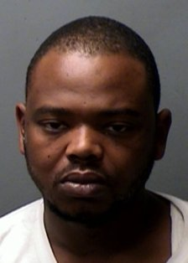  B/M DOB: 02/14/84  Hgt: 5’07” Wgt: 180  Hair: Blk Eyes: Bro  LKA: 901 E. Shaw St  Wanted For:  Aggravated Assault Deadly Weapon X2,  Unlawful Possession Firearm Felon  BY  FWPD | Juan C. Villalva  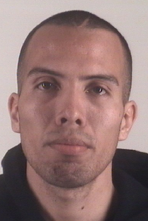  H/M DOB: 09/13/83  Hgt: 6’00” Wgt: 150  Hair: Bro Eyes: Bro  LKA: Unknown  Wanted For:  Theft $1,500-20,000  X3  BY  Tarrant Regional Auto Crimes Task Force | Lori M. Phillips  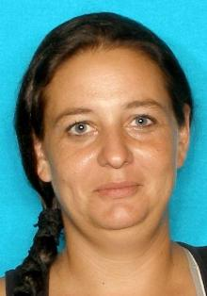  W/F DOB: 02/10/78  Hgt: 5’04” Wgt: 150  Hair: Bro Eyes: Blu  LKA: 11093 Alta Vista #34  Wanted For:  Sexual Assault Under 17  BY  FWPD | Billy D. Turner  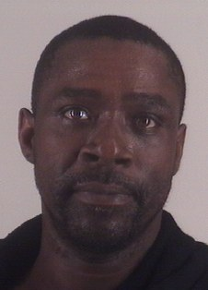  B/M DOB: 08/27/66  Hgt: 6’00” Wgt: 184  Hair: Blk Eyes: Bro  LKA: 3535 Ave I  Wanted For:  Sexual Assault  BY  FWPD | Roderick Jones  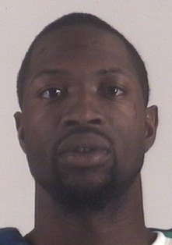  B/M DOB: 10/23/86  Hgt: 5’11” Wgt: 190  Hair: Blk Eyes: Bro  LKA: 7301 Ederville Rd #2322  Wanted For:  Assault Bodily Injury Family Member  BY  FWPD
Eric Betancourt  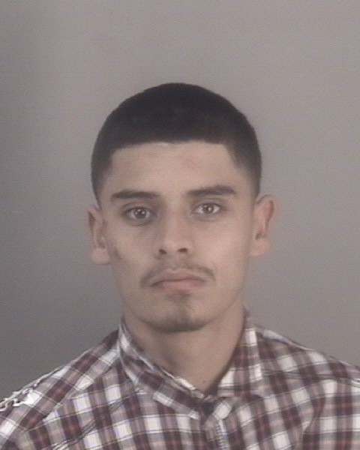  H/M DOB: 11/14/90  Hgt: 5’07” Wgt: 140  Hair: Blk Eyes: Bro  LKA: 2611 Roberts Cir  Wanted For:  Attempt to Take Weapon from Officer  Bail Jumping  BY  TCSO | Malcom Wommack  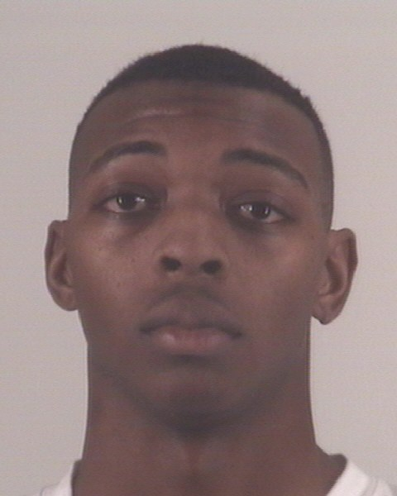  B/M DOB: 06/25/90  Hgt: 5’07” Wgt: 145  Hair: Blk Eyes: Bro  LKA: 2649 Hawco Dr  Wanted For:  Possession of Controlled Substance 1-4G PG1  BY  TCSO | Caleb Kratzer  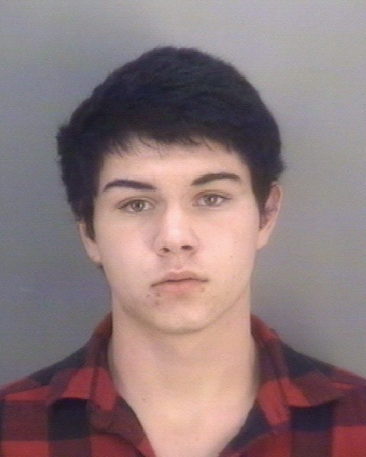  W/M DOB: 12/06/93  Hgt: 5’10” Wgt: 152  Hair: Bro Eyes: Haz  LKA: 6734 Silvercrest Dr  Wanted For:  Drug Free Zone – Controlled Substance U/28 Gram  BY  TCSO | Tony Douglas  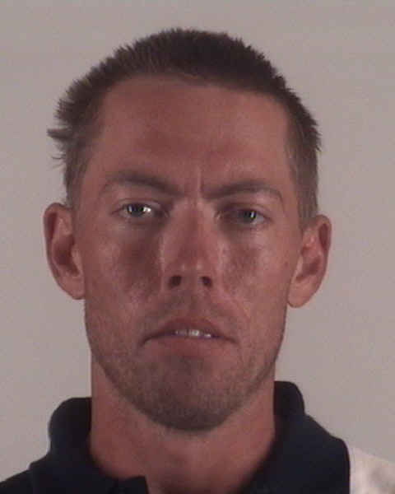  W/M DOB: 07/13/80  Hgt: 5’10” Wgt: 155  Hair: Bro Eyes: Blu LKA: 2400 Cypress St  Wanted For:  Possession of Controlled Substance U/1G PG1  BY  TCSO | Gustavo Lombardo  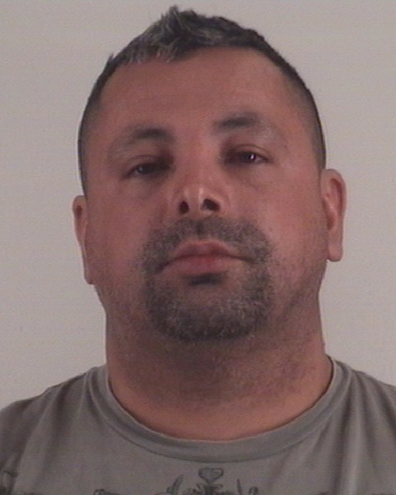  W/M DOB: 08/02/70  Hgt: 5’07” Wgt: 180  Hair: Blk Eyes: Bro  LKA: 5551 Parker Henderson Rd  Wanted For:  Possession of Child Pornography  BY  TCSO
Arlington PD Most Wanted List is available in the newspaper on Sundays and online.
For access to Fort Worth Police Dept. Cold Case Homicide Suspects go to www.fortworthpd.com/coldcase.

